**Versa64case v2 Rev. 0**

**Test Description description**

# Devices under Test

* Versa64case v2 with accessible configuration with Versa64Cart and long jumpers
* Versa64case v2 without accessible configuration with Versa64Cart and short jumpers
* Versa64case v2 without accessible configuration with Epyx Fast Load

# Test Execution

## Mountability

* Both, the Versa64cart and the Epyx FastLoad cartridge PCBs fit inside the cases.
* The short jumpers do not collide with the top shell
* The screw (16mm and 13mm) fits into the case and reliably holds both halves together

## Fits into the Expansion Ports

Both versions of the case are tested with different computers

* The cases fit into the expansion port of the C64 bread bin (Figure 3)
* The cases fit into the expansion port of the C64C (Figure 2)
* The cases fit into the expansion port of the C128 (Figure 1)

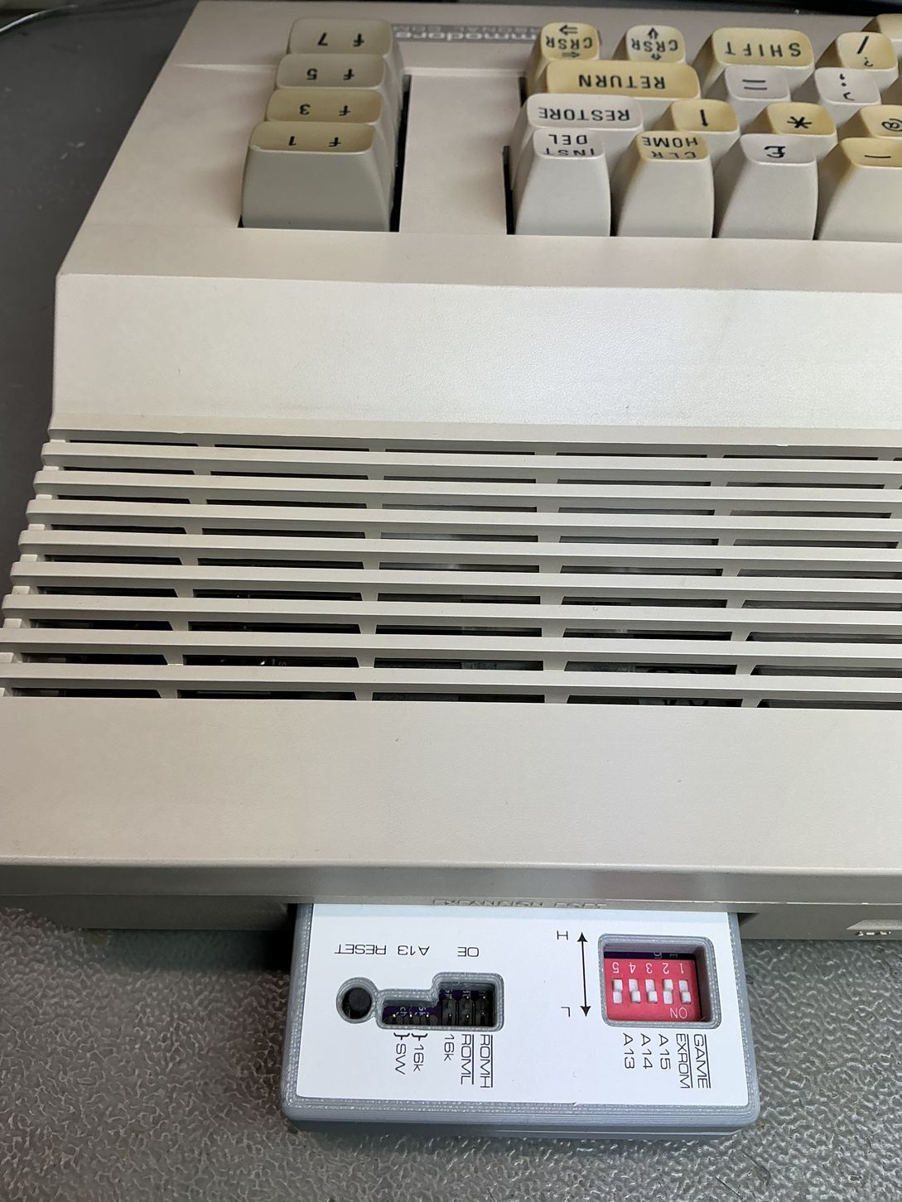

Figure 1: Test with C128

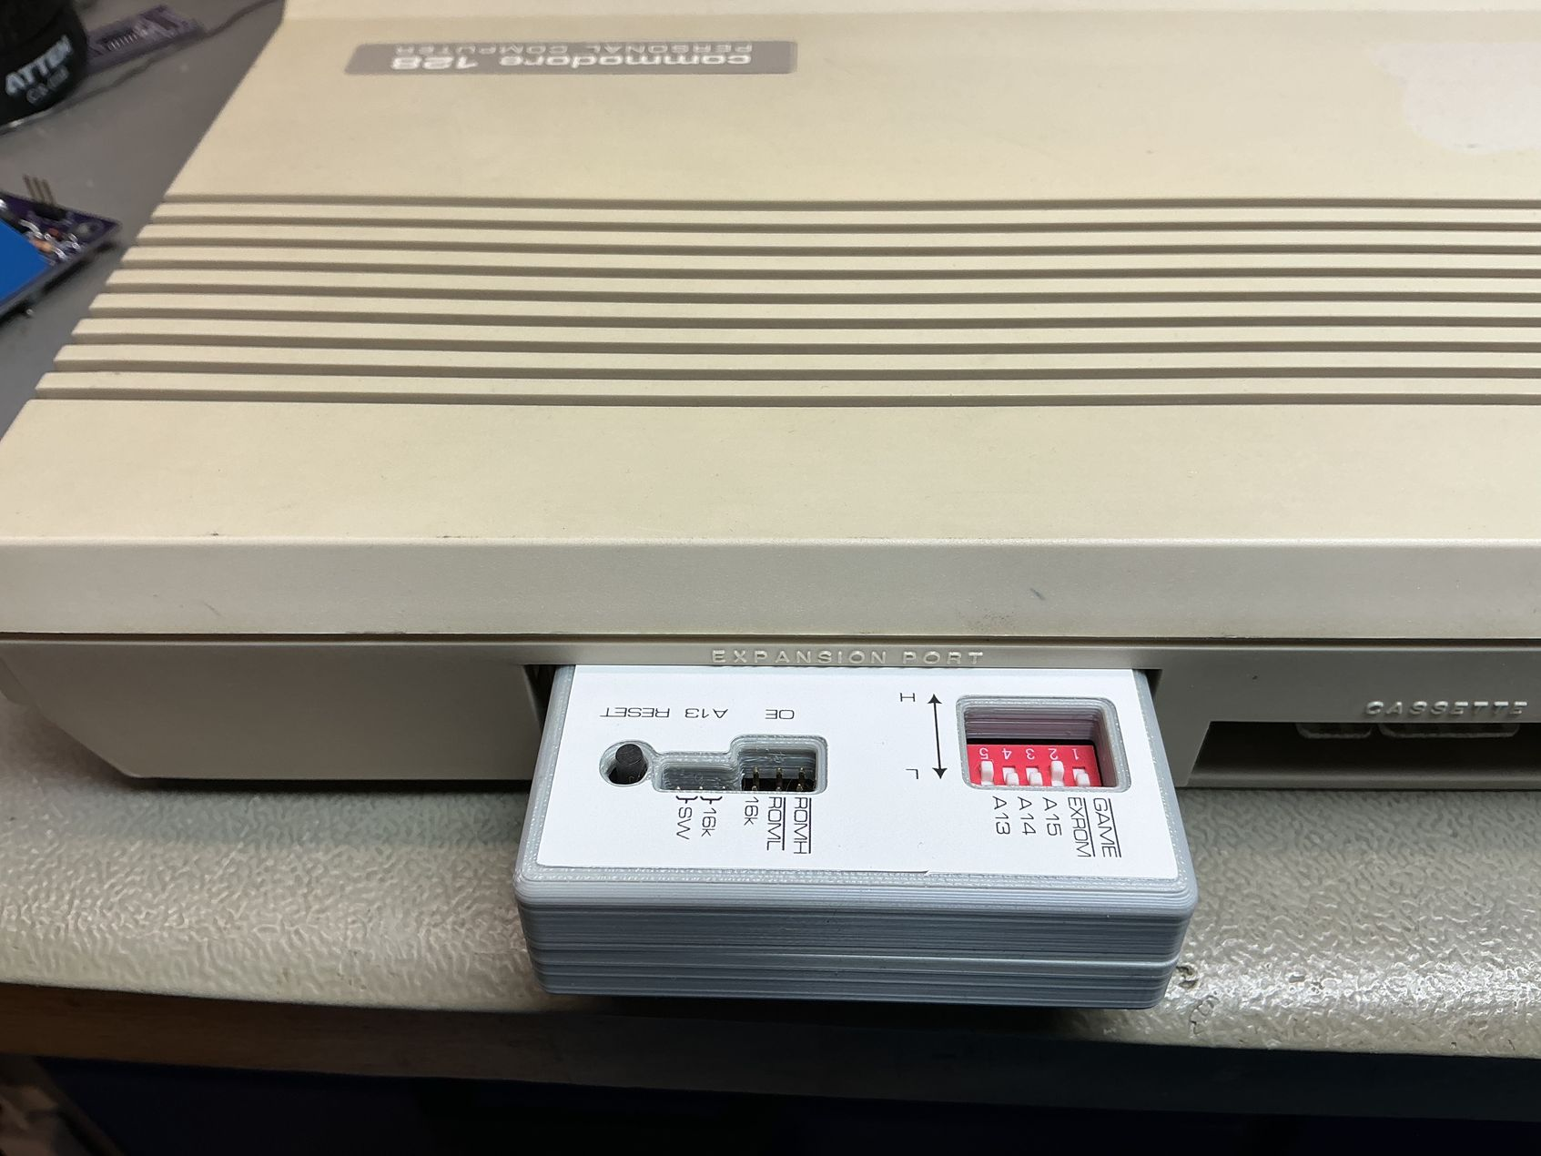

Figure 2: Test with C64C

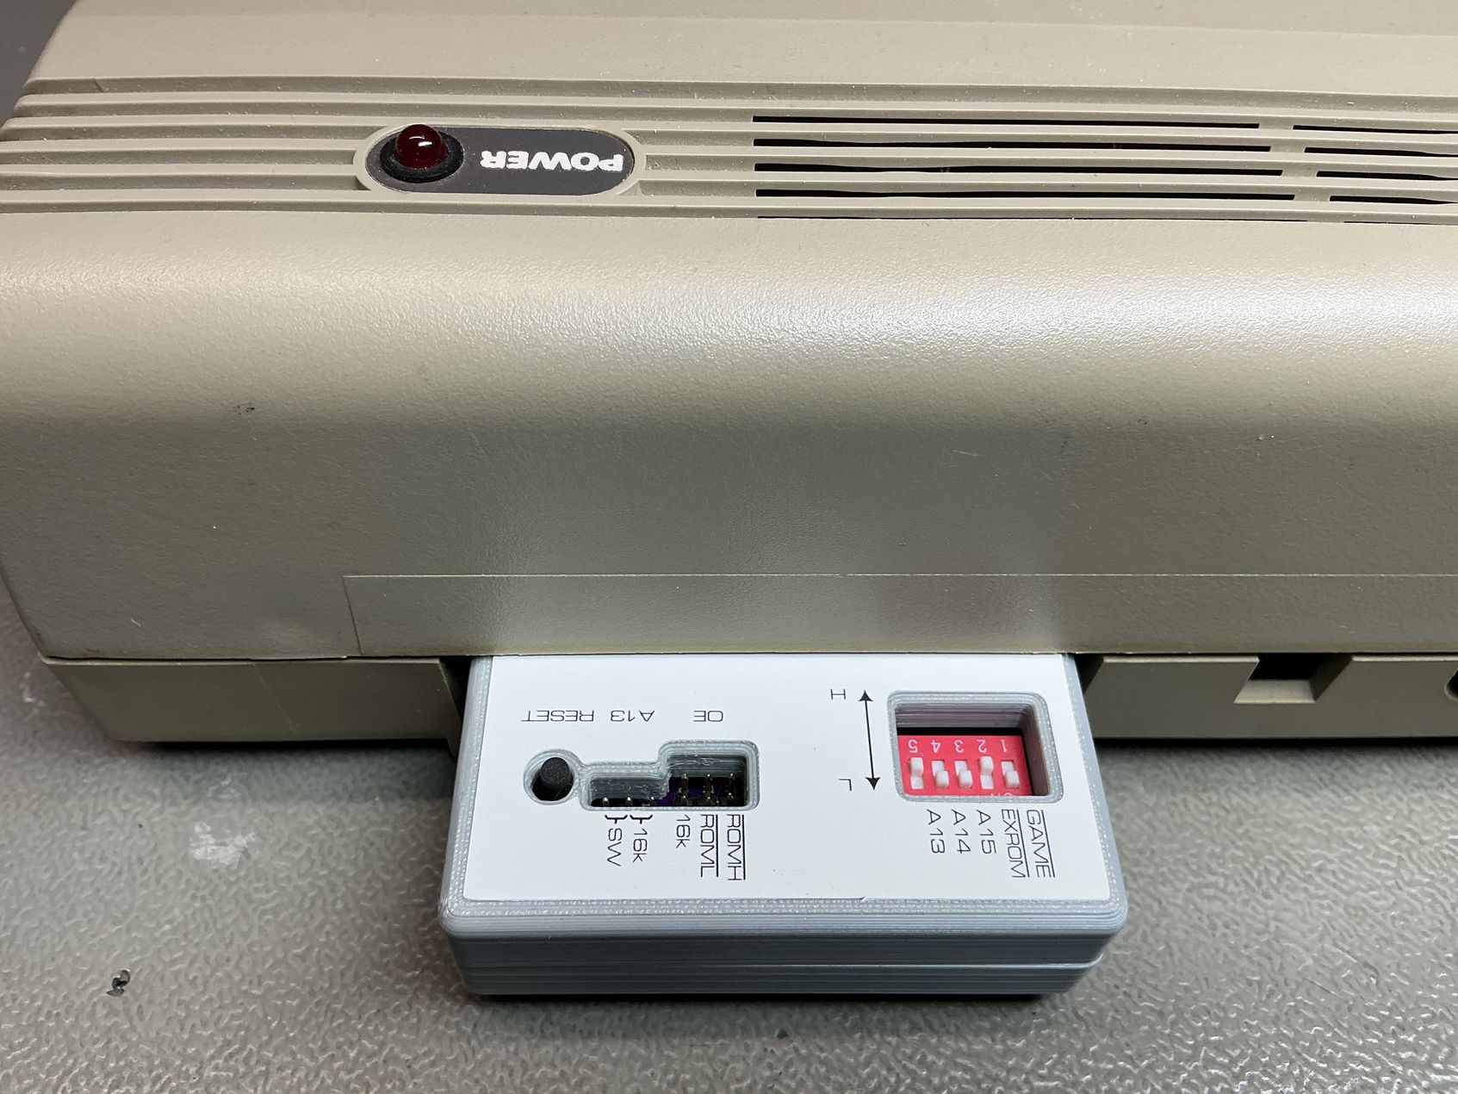

Figure 3: Test with a bread bin C64

# Conclusion

The Versa63case v2 works/fits with all known configuration.